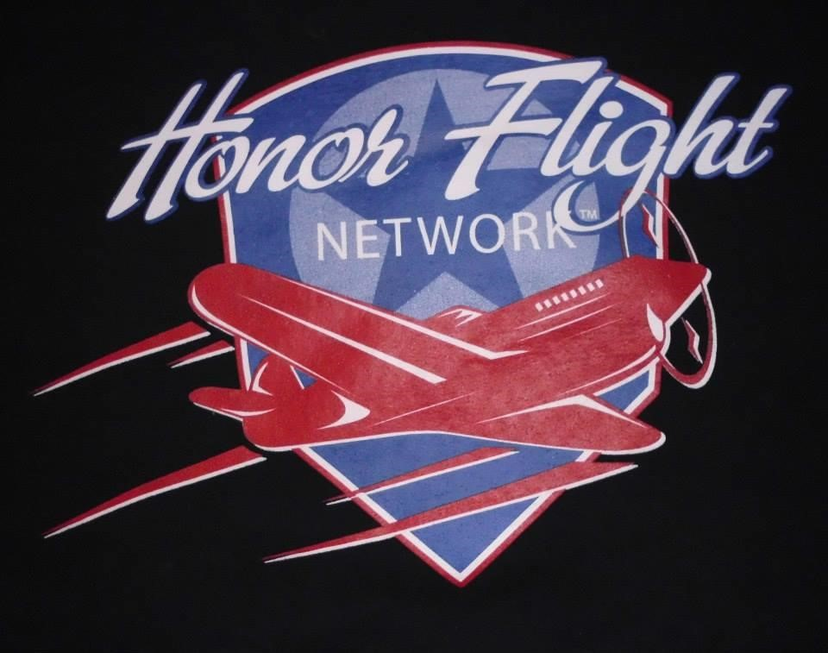
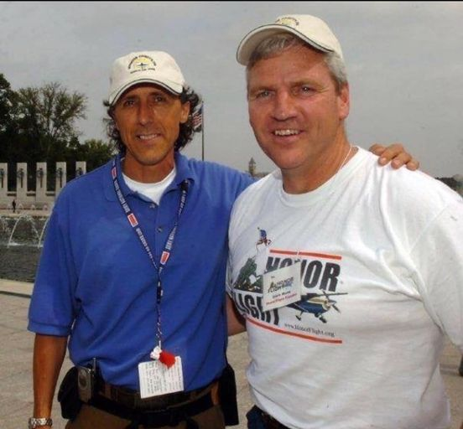

Jeff Miller & Earl Morse
Founders of Honor Flights in 2005
11/01 (Sat) | HF Cleveland  (CLE) | SWA #2076  Arrival: 07:10 | 24 | 24
11/01 (Sat) | HF Central Florida  (MCO) | SWA #2894  Arrival: 09:25 | 30 | 18
11/01 (Sat) | HF Southern Arizona  (MDW) | SWA #TBA  Arrival: 16:15 | 24 | 24
11/04 (Tue) | HF Northern Arizona  (PHX) | SWA #4058  Arrival: 18:20 | 35 | 17
11/07 (Fri) | LONE EAGLE   (Flights Vary) |  | 46 | 46
11/08 (Sat) | HF Space Coast  (MLB) | Allegiant #4911  Arrival: 08:06 | 50 | 50
11/10 (Mon) | HF Jackson Heights  (MCI) | SWA #3507  Arrival: 08:50 | 26 | 25
11/13 (Thu) | HF Nevada  (RNO) | SWA #1925  Arrival: 16:10 | 45 | 5

Gate Access Passes (GAP’s): The email account to request gate access passes (GAPs) is bwigap20@gmail.com. The deadline for requests is 36 hours prior to the first flight of the day. Please enter GAP Request(s) in the subject line and the date(s) and Airline Hub(s) you are requesting GAP’s for in the body of the email. Unless you are meeting the first flight of the day, please let us know which flight you will be meeting. This helps us with volunteers being available for you to pick up your gate pass and drop off your parking ticket for validation. If your plans change and you will not be at the airport, please advise through bwigap20@gmail.com account up to and including the day of the flight so we do not have a volunteer waiting for you instead of greeting the Veterans.. GAP requests received after the 36-hour cut off will not be honored.

If anyone encounters problems, let me (Jennifer) know – (443)-995-2221 and we can try and sort it out so you don’t have to pay.

Please note that we cannot request gate access passes if Allegiant or Breeze Airlines are the only flights coming in that day.

The requested format for submitting is:

First name, Middle initial, Last name, date of birth, (mm/dd/yy format) and gender. Please submit it in this format:

John D. Smith, 03/16/99, male

Requests with multiple names should be sorted by last name. When you are submitting a request where several people have the same last name, please also sort it by first name. For example:
Amy M. Smith, 04/21/99, female
John D. Smith, 03/16/99, male

Please check that your information is correct before submitting as those requests received that are not in the requested format will be returned with a request to reformat.

If you are military, please note on your request so we can assign you to the correct listing. If you do not receive a response to your request within 24 hours, please email jjabner@verizon.net so she can respond. Important: if your plans change and you will not be at the airport, please advise through the bwigap20@gmail.com account up to and including the day of the flight.

Please park in the hourly garage and bring in your parking ticket for validation at door #10 along with a government issued picture ID. Please note face coverings are optional at BWI airport. The parking validation deadline is 60 minutes before the flight arrival time. Everyone, babes in arms included, needs a GAP. A picture ID is not required for those under the age of 18. Transportation Security Administration (TSA) no longer requires removal of shoes. If your shoes set off the alarm, you will be asked to take them off and go through the screening again.

When you enter the hourly garage, you will get the new type of ticket with a QR code on it. We now have a scanner in the Pathfinder office we can use to scan the QR code on the ticket and it will confirm that it has been validated. So your original parking ticket will be returned to you and when you exit the garage you can use any lane - credit card and prepaid lanes included - and scan on the machine at the exit lane. You should do this even if you go to a cash lane. Just scan, you will keep the ticket, and the barrier bar will rise to let you out.+

Pick up point for all GAPs and drop off of parking passes will be door #10 just past the Frontier Airlines check-in desk on the upper level. This gives us more space to congregate. This will also enable us to get parking passes validated more quickly. The pick-up point for validated parking passes will be at the same location. If you do not find a yellow shirt at this location, please check with the
D Information Desk located near the United check-in desk.

Lone Eagle: A Lone Eagle is a Veteran whose application has been in our national office for one year or more, yet they do not live close to one of our existing hub cities. Our definition of “close” is within a 120-mile radius of the airport used by the closest hub. When we discover a veteran who qualifies for this program, we will make every effort to fly them from a large commercial airport near their home. Honor Flight Network is responsible for arranging transportation for all Lone Eagle Veterans.

There are 46 Veterans scheduled throughout the day on several airlines.

The Lone Eagle Veterans will be flying into BWI airport at different times of the day. They will be picked up by a Hilton bus and taken to the Airport Hilton where they will check -in, get reception bag(s), head to their rooms to freshen up and come back down to the lobby area to meet other Veterans arriving. Later that afternoon they will be served dinner. They will retire for the night and prepare for pick-up by a bus(s) early next morning for the trip down to their Memorials.

If you would like to meet and greet some of them, no GAP required, we suggest going straight to the hotel usually late morning/early afternoon and wander around looking for these Veterans. Conversations are encouraged.

If you are a member of AL Post 156, please add my email address,
pinnochle@aol.com, in the cc section – this allows our Post to track participation by our members and family/friends. Take pictures if possible and wear your AL cover.

Thanks in advance!

Randy Bohn
Honor Flights Committee Chair and Post Historian
AL Post 156
P.O. 2416
Ellicott City, MD 21043
pinnochle@aol.com

