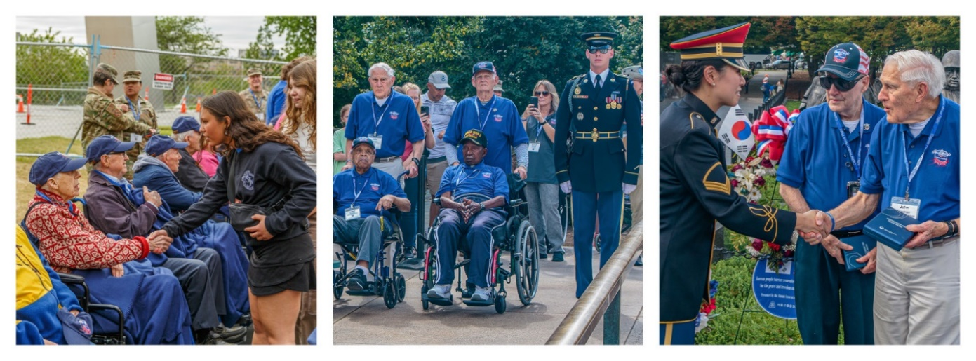
Capital region honor flight
Operation “Welcome home”
Come out to greet our Senior War Veterans as they return from their Day of Honor. This Honor Flight is made up of Veterans from WWII, Korea and Vietnam.
Where: American legion post 60
2 main street, laurel md 20810
When: June 4th, 2025
Please arrive between 6:30 and 7:15 pm – plenty of parking
Show up, cheer loud, shake a hand!

Greeters will be asked to congregate at your cars or inside the lounge area of the American Legion. The Veterans will be in the dining area eating dinner and not aware of the gathering. At the appointed time, greeters will be escorted into the dining room to cheer and visit with the Veterans. Homemade banners & signs /American Flags / hugs encouraged.
Let’s show these veterans how a grateful community welcomes our warriors home!
for more info-Call/text jenny brawley at 571.721.0068

